

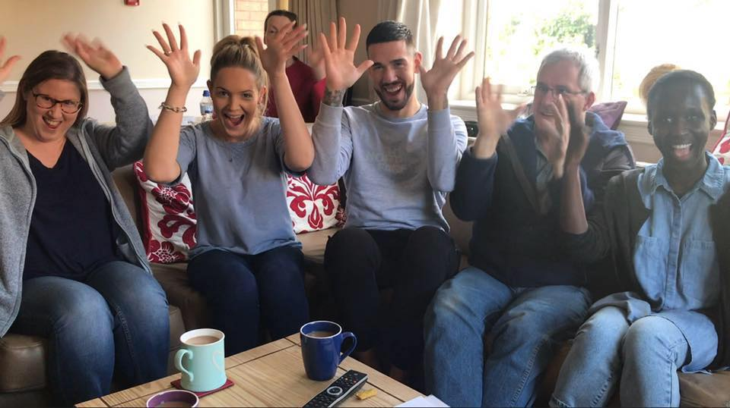

**Specialist Support Worker**

Candidate Brief

March 2021

**Overview**

Thank you for your interest in this exciting role. We hope that this pack gives you all the information you need to make your application.

We have ambitious plans to grow our social care services in line with our three-year plan.

Here at SignHealth we are currently recruiting for a Specialist Support Worker to join our team in taking on the exciting challenge of providing high quality health and social care support to Deaf individuals, many of whom who have mental health conditions.

You will be encouraged to learn and develop British Sign Language skills if you don’t already, so

that you can communicate with our teams and grow effective relationships with our deaf

colleagues. We provide services directly in British Sign Language (BSL), we work in partnership

with the NHS and local authorities and we also campaign for change.

75% of our staff at SignHealth are Deaf, and almost all of our staff in services are fluent sign language users.

Our work is varied and aims to give Deaf people easier access to healthcare and information, as well as providing services which are not provided elsewhere.

Some of our work is funded on a case by case basis by the NHS or local authorities, and some is funded entirely by grants from trusts or by donations from individuals.

“We are a passionate and caring Deaf-led team working towards a future where there are no barriers to good health and wellbeing for Deaf people.”

**About us**

The charity was set up in 1986 as the Anastasia Trust in response to a lack of services for Deaf people with mental health issues. Over three decades, we’ve grown to provide a range of services that improve Deaf people’s lives.

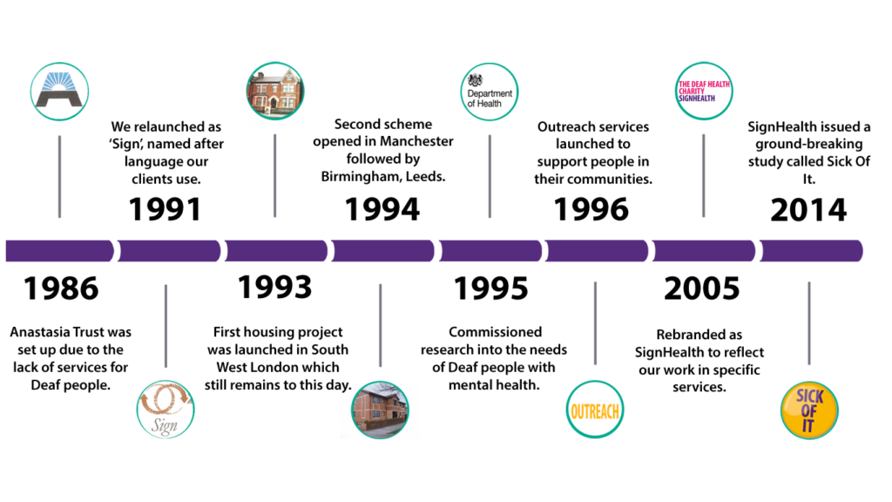We have grown to deliver a range of services that improve the health and wellbeing of Deaf people. In the last thirty years we have set up a number of care homes, provided advocacy and outreach services, supported Deaf people at risk of domestic abuse, delivered therapy in British Sign Language, carried out important research and made vital information more accessible to Deaf people.

Our work is varied and aims to promote easier access to healthcare and information. We partner with the NHS and other services and take on projects, carry out research, and raise awareness.

The world has changed significantly since SignHealth began, not least huge advances in technology and the changing health and social care landscape. Things have changed within SignHealth too. In July 2017 we relocated our Head Office from Buckinghamshire to London. We have a new, award-winning, Board of Trustees, a refreshed strategy and we are focused on ensuring that the organisation is financially and commercially sustainable. There is a great deal to do to improve Deaf people’s health and wellbeing and we are determined to make a significant difference through our work.

**What we do**

**Social Care**

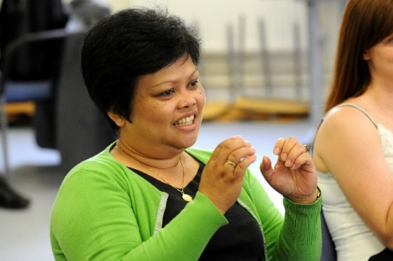Our registered care homes, all rated Good by CQC, are for Deaf people with complex and long-term mental health issues. This is how we first began, and they remain a hugely important part of our services portfolio. Our five care homes give residents their own bed-sit flat, and the care home staff help the residents to build independence and increase confidence, as well as prompting and supervising medication. All residents and staff are sign language users, which helps to end the isolation many Deaf people experience when they are inappropriately supported in hearing services.

Many of our care homes also have outreach services which support other Deaf people living in their own homes to increase their independence and take part in their local community. Our London Outreach service also runs a Supported Housing service for Deaf people in Wandsworth.

**Therapies**

SignHealth runs the only IAPT-compliant, BSL psychological therapy service for Deaf people with depression, anxiety or similar mental health conditions. Sessions are carried out entirely in sign language, with a therapist who is fluent and often Deaf themselves. It means there is no interpreter in the room, which would slow down communication and reduce the intimacy which is important to this kind of treatment. An online service is now up and running which will enable more people across the country to access therapy in BSL.

**Domestic Abuse services**

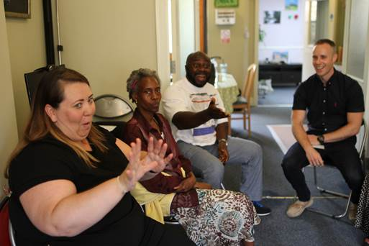Our Domestic Abuse service is a unique service that supports Deaf men, women and children who are suffering domestic abuse. This is the only service in the UK and gives help and advice on how to be safe, and where to find refuge.

The service is available in London and the South East although remote support is available across England. We have plans to expand this much needed service across the UK. The service also works with Deaf children and young people, teaching them about healthy relationships and staying safe online.

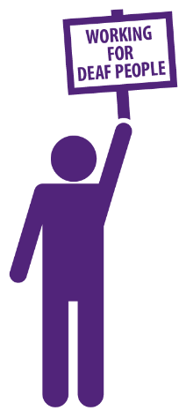**Campaigning and Research**

Campaigning is an important part of our work, trying to change the way things are done so that Deaf people get an equivalent service to hearing people. We are raising awareness among the hearing public, offering solutions to health service workers, and pushing for change from the NHS and government.

In 2014, we launched an important piece of research, ‘Sick of It’ which showed just how disadvantaged Deaf people are in our current health system.

**Fundraising**

We’ve got a strong history of fundraising at SignHealth and we want to increase our fundraised income in the future too. Whether from trusts, grant makers, central government or private individuals we have an ambitious growth strategy for SignHealth which will need strong and reliable income streams.

**

**Follow us**

 @SignHealth

 @SignHealth

@SignHealthCharity

**Job Description – Specialist Support Worker** 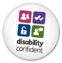

Background

1.1 The Deaf Health Charity SignHealth is a registered charity.

SignHealth is committed to bringing better healthcare and equality of service provision and healthcare access to Deaf people within the UK. Improvements will be made through research, campaigning and partnership working with Deaf people, Deaf organisations, health services and other charities.

SignHealth provides services to Deaf people experiencing mental health problems and/or complex needs. At present the organisation is working in the fields of supported living services, advocacy, outreach, psychological therapy and health promotion.

1.2 As a Support Worker you will be responsible, with the Project Manager and the other staff members, for the successful running of a supported housing scheme for Deaf people with additional needs of a behavioural, emotional and social nature. The objective is to enable the tenants to become as independent as possible.

2 Accountability

2.1 You will be responsible on a day-to-day basis to the Service Manager.

3 Responsibilities

Key tasks:

3.1 To make sure each person is treated as an equal

a. By making sure what you do in your work or outside does not discriminate against people.

b. By making sure all information about your work and the residents is kept confidential.

c. By encouraging and supporting other people in making their own choices.

d. By making sure that each person is given and fully understands their rights.

e. By accepting and respecting each person as an individual with their own personal beliefs, ethnic background, language, identity and culture.

f. By using communication that each person can understand and feels comfortable with.

3.2 To encourage and support people to be independent and not dependent on others.

a. By supporting tenants in taking care of their personal hygiene, cleanliness, and appearance.

b. By supporting residents in their leisure time, interests, employment, and education.

c. By helping and supporting residents when they tell us or other people about abuse or other worries.

d. By helping residents who have communication difficulties.

e. By involvement in managing aggressive abusive behaviour.

3.3 To support residents in developing the skills they need to be independent.

a. By enabling residents to use information and services in the community.

b. By supporting residents to manage their homes and themselves.

c. By encouraging residents to look after themselves when they can.

3.4 To help residents carry out their individual Support Programmes

a. By encouraging and following Support Programmes that have been agreed with residents – person centred planning.

b. By assisting residents to start up activities and programmes.

c. By helping residents to improve the skills they have, rediscover lost skills and to develop new ones.

3.5 To give support that maintains and develops the resident’s identity and their relationships

a. By supporting residents to develop themselves and their relationships.

b. By providing on-going support to residents.

c. By supporting residents in relationships which are or could be difficult.

d. By assisting residents to keep in contact with other people so that they do not become isolated or alone.

e. By assisting residents to develop community-based networks.

3.6 To help make sure the workplace is right for effective high-quality support to be given

a. By getting, keeping, and passing on records or other information about the support given to residents.

b. By making sure SignHealth rules and guidelines, policies and procedures are followed.

c. By following the Health and Safety at Work policy.

d. By making sure that property belonging to SignHealth and residents is kept safe.

e. By agreeing policies about the running of the house with residents and the Support Team and following these.

f. By taking part in all training that is organised by the Manager or organisation.

g. By completing successfully, the staff development programme and meeting with your supervisor every month.

Other tasks

3.7 Assisting in the development of the housing project and other SignHealth projects.

3.8 Completion and monitoring of care plans.

3.9 Being the keyworker for residents, undertaking assessments, taking part in service reviews etc

3.10 Ensuring that all communication is clear at all levels (staff, residents, social workers, head office, statutory bodies, police, fire services etc).

3.11 To be responsible for the safe running of the project when alone (for example at night).

**Specialist Support Worker**

**Person Specification**

The skills and knowledge required of a Specialist Support Worker in SignHealth.

• Can work with people with mental health problems and complex needs

• Demonstrates good interpersonal skills

• Demonstrates good communication and written skills

• Demonstrates good organisational skills

• Can use British Sign Language (training will be given)

• Understands responsibilities and boundaries

• Able to support residents in all areas including medication

• Able to understand and create support plans

• Demonstrates an ability to work within SignHealth’s policies and procedures

• Able to develop and maintain best practice principles within social care.

• Works effectively within a team.

• Able to undertake successfully NVQ or equivalent social care training

• Undertakes the role of key worker for a resident or a number of residents as required

• Understands the importance of confidentiality

• Is cheerful and outgoing

• Is patient and thoughtful

• Uses initiative and can work unsupervised under pressure

• Works flexibly

Candidates that do not initially possess all the skills and knowledge should show a desire and motivation to develop these within a given timeframe.

**HOW TO APPLY**

We hope that the information provided has enabled you to make an informed decision about your application. Before you apply, please ensure you have read the job description and person specification in detail.

Applications should comprise a CV, including details of two referees. Please also provide a supporting statement outlining the reasons behind your application. This should respond closely to the person specification, showing how you meet the requirements of the role.

Our diversity monitoring form (available on request) should also be completed and returned.

We positively welcome applications from deaf people and disabled people.

All documents should be emailed to: [npatterson@signhealth.org.uk](mailto:npatterson@signhealth.org.uk)

**Please include your name in the subject field.**

**Contact**

If you would like to arrange an informal discussion about the role or the process, please contact [npatterson@signhealth.org.uk](mailto:npatterson@signhealth.org.uk)