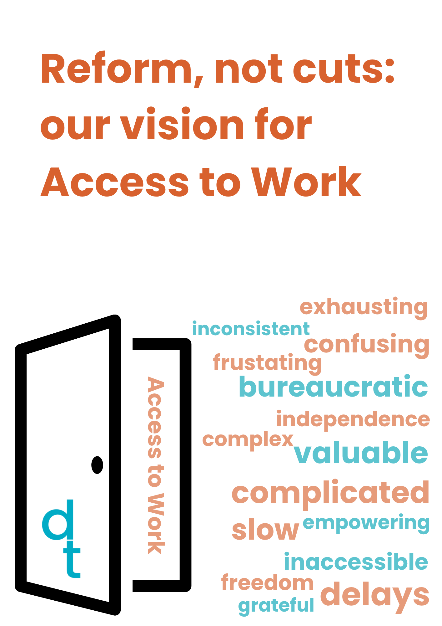

**Reform, not cuts: our vision for Access to Work**

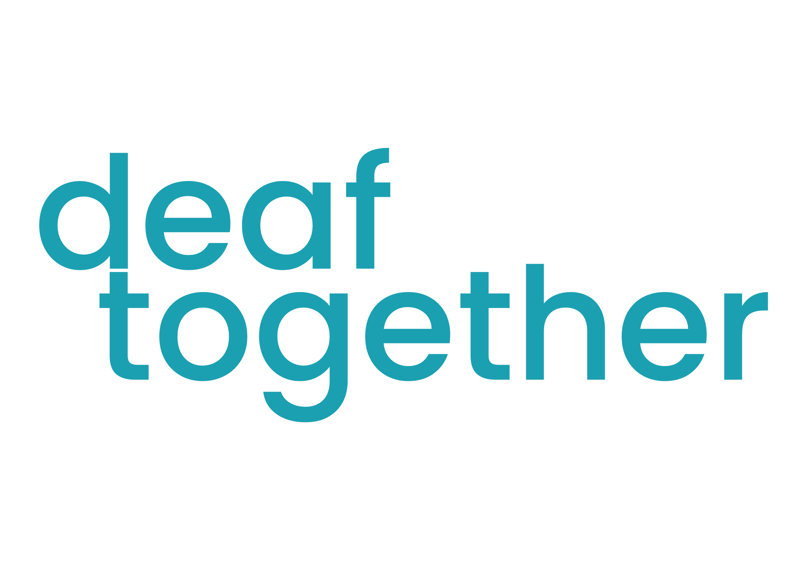 [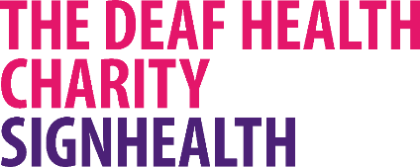](https://signhealth.org.uk/)

Contents

What is Access to Work? **3**

Why this matters **3**

Problems and solutions **5**

Delays **5**

Inaccessible and bureaucratic processes **5**

Lack of deaf awareness **7**

Lack of awareness and support from employers **8**

Lack of support for career progression **9**

What needs to change **10**

Key data **11**

What was your experience of Access to Work like? **11**

How can Access to Work be improved? **16**

Why have you not used Access to Work? **18**

Self-employment **20**

Case studies **22**

Conclusion **29**

Research and terms **30**

# [A group of hands with text AI-generated content may be incorrect.](https://vimeo.com/1101221276/209b18e40a)What is Access to Work?

[Access to Work (ATW)](https://www.gov.uk/access-to-work) is a government scheme that helps many disabled people get into work and stay in work. It can pay for things like:

* British Sign Language (BSL) interpreters
* Notetakers
* Specialist equipment
* Travel costs

All of which can help us to do our job without worrying about how we will communicate with our colleagues or access information that is shared with us at work. For us, this support is often the difference between being able to do our job or not. They are our basic, essential, access needs.

At SignHealth, a deaf health charity, we are facilitating the deaf together campaign. This campaign focuses on employment – a topic chosen by members of our community - as we know that barriers to employment have an impact on our health and wellbeing.

### Why this matters

Access to Work is a scheme used by a range of disabled people to access work. As a deaf charity, our primary focus is accessibility for deaf people as this report reflects. In 2024, Access to Work recorded that there were 6,090 [1]deaf and hard of hearing claimants using Access to Work. That makes deaf and hard of hearing people the second largest users of Access to Work after people who use it for mental health conditions. Whilst Access to Work is a valuable and vital scheme for us, it does not work the way it should.

We’ve been told by deaf people who interact with the current Access to Work system that they are facing long delays in getting their support in place, the processes to apply and renew support are confusing and complicated, and some are telling us that they are facing cuts to the support they rely on. We are seeing firsthand how frustrated, disempowered, and exhausted deaf professionals are feeling from dealing with the inefficiencies of Access to Work.

That’s why we are publishing this report on Access to Work, recognising the value of it as well as highlighting the changes that need to be made to the scheme in order for it to truly work for deaf professionals. Access to Work should benefit deaf professionals without adding an additional burden of having to deal with an inaccessible system, extreme delays, and an overall confusing and complex process. Access to Work should open up opportunities, not create more barriers.

In this report, the following points will be covered:

* Core problems with Access to Work
* What needs to change – the solutions
* Key data
* Case studies

The following information, quotations and data were sourced from the deaf together Deaf at Work survey conducted between October and December 2024. For more information on the methodology used, please see page 30.

# [A group of hands with text AI-generated content may be incorrect.](https://vimeo.com/1101223491/c0bc74ed50)Problems and solutions

**What are the core problems with the current Access to Work system?**Deaf people need Access to Work to ensure that we have a fair and equitable experience at work, can progress in our careers and be fully included in decisions about our future. Yet, too many have told us that the system is not working for them; from extremely lengthy delays to a lack of awareness of their access needs. Access to Work should remove barriers, not create them.

Based on what deaf professionals, BSL interpreters and support workers have told us, there are five key problems which highlight a need to reform the current system.

**“Deaf people need support from day one, not six months plus into a job.”** - Abigail

**1**

### Delays

The most frequent issue found was extreme delays. Deaf people are waiting several months to get support in place; the longest wait was 10 months. This is 4 months over the traditional 6-month probationary period. That means deaf people are working without their support being approved and in place. How can they thrive and work to their full potential if support is not there? These delays lead to:

* Missed career opportunities
* Lack of career progression
* Difficulty in social integration at work, having an impact on mental health
* Finding it difficult to settle into a new role with no support
* Having to self-fund access or employers funding
* Having to leave a job because there is no communication support

**2**

### Inaccessible and bureaucratic processes

Many deaf people have to deal with excessive paperwork and little to no BSL access during applications and renewals for Access to Work. This forces deaf people to navigate lengthy processes in a language that is not their first or preferred language. This is an overwhelming, additional, burden, which hearing applicants do not have to face. Participants reported:

* Struggling to understand what support they are entitled to
* Difficulty navigating the application process
* Difficulty in completing forms that are not designed to be accessible to deaf people.

There is no central, accessible list of eligible items or services that deaf people are entitled to as part of their Access to Work support. The forms that deaf people are expected to complete, within tight deadlines, lack plain English, BSL translations, or visual guides. Most of the questions asked on the forms are jargon heavy and require detailed written responses that place a barrier for deaf BSL users.

Currently, there is no option to complete the full application in BSL. The Access to Work system also lacks proactive support for deaf people applying or renewing their Access to Work. There are few or no caseworkers that are fluent in BSL. This inaccessible process, combined with extensive paperwork, makes for a challenging experience.

**“The service is very slow, especially with their payments and customer service. Even when I want to ask a simple question, it takes them over 30 working days to respond via email.”**   
–Jephta

**“It needs to be a simple, straightforward process with clear plain English and BSL access.”** - Laura

This is especially true for first time applicants, who might not be aware of what Access to Work can cover, what their rights are, and what they are entitled to. As a result, the burden of managing this complex and confusing system falls onto deaf people; making Access to Work, a system meant to support deaf people into work, another barrier to overcome.

**3**

### Lack of deaf awareness

A recurring and serious concern found within responses was the lack of deaf awareness amongst Access to Work staff; this includes both assessors and case managers. Many deaf people told us that they felt misunderstood, frustrated, and disrespected, when dealing with Access to Work applications and renewals.

Assessors and case managers often:

1. Ask inappropriate or irrelevant questions, highlighting the lack of understanding of deaf people’s communication needs in working environments. For example, asking deaf people why they need a BSL interpreter if they can speak.
2. Rely fully on phone communication, despite knowing that the applicant or claimant is deaf. Many deaf people told us that they have been asked to call back to confirm details. When there is Video Relay Services available, there have been several occasions where the deaf applicant or claimant reported no interpreters turning up. Overall, this causes stress, confusion, and communication breakdowns.
3. Question access needs that are longstanding and unlikely to change, forcing deaf people to justify why they need a BSL interpreter or a notetaker and explain their needs year after year, even when those needs inevitably stay the same.

**4**

### Lack of awareness and support from employers

A significant number of participants told us that their employers either were not aware of Access to Work and how the scheme works, or were reluctant to support them with the scheme, for example approving or signing off their budget or claims. This kind of disengagement can cause major delays, discourage deaf people from applying, or lead to workplace tension.

Employers are one common barrier delaying deaf professionals accessing and using their Access to Work budget. This includes delays in signing off budget quotes, responding to assessor's queries, and completing referral paperwork, all because they are not familiar with how the system works.

**“I’m waiting for my line manager to refer me. It’s been two months.”   
–** Anonymous

Deaf employees are being made to feel that applying for Access to Work is a burden to their employers. Some respondents shared that they were discouraged or ashamed to ask for support that legally, they are entitled to, out of fear of being seen as difficult or demanding.

**“Work won’t support me; they’re pushing me not to get Access to Work.” -**Anonymous

This leads to:

* Delays in getting support in place – especially for those starting new roles or being promoted
* Feeling isolated with no clear guidance or support in the workplace
* Extra stress from the burden of doing additional labour to educate their employers
* Without clear support and resources for employers to understand what Access to Work is, and what their role as an employer is, the Access to Work system will continue to require deaf people themselves to educate their employers. It is not sustainable or fair.

**5**

### Lack of support for career progression

Under the current Access to Work system, deaf respondents reported that when they request a change of circumstances to their Access to Work profile due to promotion, changing jobs, or becoming self-employed, they are frequently met with needless reassessment, feelings of worry and uncertainty, or straight cuts to essential support.

**“They challenged me for the same needs I’ve had for 20 years.”**

- Anonymous

Instead of supporting ambition and independence for deaf people seeking career progression, the current Access to Work system too often undermines it, creating a situation where the deaf professionals face barriers just for trying to move forward in their careers.

Each time a deaf person’s employment circumstances change, they have been typically required to:

* Submit a new application or go through a full reassessment
* Justify long-standing, unchanging, access needs that have previously been approved
* Wait, sometimes for months, for their budget to be approved for support to be reinstated or adjusted, leaving them without support in the meantime.

This comes at a time when the Government has undertaken its Pathways to Work consultation, which closed 30 June 2025. Deaf people’s views and lived experiences must be fully considered in the decision making of any changes made to Access to Work, before, during and after the consultation.

If any decision is made to cut Access to Work budgets for deaf people in work, that will inevitably result in a net increase in government spending on unemployment benefits, as deaf people are forced out of work due to lack of support. This will also reduce overall tax revenue from working deaf professionals, as well as from their Language Service Professionals (LSPs). We want Access to Work reform, not cuts.

# What needs to change

**](https://vimeo.com/1101224656/7598c02aac)**

There is a clear need for changes to be made to the way that the current Access to Work (ATW) system works. If these changes are not made, deaf people will continue to experience barriers in getting in work, and progressing in their careers.

If the Government wants more deaf people in work, why are there existing systems like Access to Work that are not efficient, leading to more deaf people leaving work or not able to seek work because they cannot get the support, they need in place?

We propose the following changes, which are informed by our community’s response to our Deaf at Work survey.

**Delays and inefficiencies**

Increase ATW staff and automate simple renewals to cut administrative waste and speed up processing.

**Budgeting and funding**

Ensure ATW funding remains stable or increases in line with responsibilities when deaf people progress in their careers.

**Training**

Introduce mandatory annual deaf awareness and culture training for ATW assessors and case managers to ensure equitable treatment of deaf applicants

**Employer awareness**

Launch an ATW Employer Toolkit and simplified claims process to increase uptake and reduce processing errors.

**Application complexity**

Introduce simplified forms, automatic renewals, and a BSL-accessible application process to cut administrative costs.

**Communication barriers**

Expand Video Relay Services (VRS) and introduce BSL-based assessments.

# Key data [A group of hands with text AI-generated content may be incorrect.](https://vimeo.com/1101230162/0eae323848)

In our survey ‘Deaf at Work’, we asked three questions on Access to Work:

1. What was your experience of Access to Work like?
2. How can Access to Work be improved?
3. Why have you not used Access to Work?

#### Experiences of using Access to Work

Only **15%**

had an overall positive experience with Access to Work.

**7%**

said the introduction of the online portal is an improvement on the previous postal system.

**37%**

told us the process of applying for Access to Work was slow and difficult.

**“Lost lots of finance because I paid first, during a time ATW delayed payment to language professionals.”**–Penny

**“Waited 5 months from application to Access to Work. Then, 3 months of emailing back and forth. A 48 hour window to be assessed or fall out of the process to start again. Then 1 month for the grant to be awarded. Still waiting on employer to get equipment 4 months later.”  
 -** Anonymous

**26%**

said that staff did not understand their needs as a deaf person, often asked inappropriate questions and didn’t provide the correct equipment needed.

**“They were rude and angry that I got promoted to a new role after I renewed. I explained that my role had changed, but they weren’t pleased. After this, I lost my confidence.” -** Anonymous

**“No clear straightforward guidance. Inadequate communication support, often they don’t realise I am deaf and would want to call me – how? Email communication is inconsistent. Limited understanding of deaf accessibility needs. Delays in providing necessary support which can be very disruptive when starting a new job.”   
–** Emma

But positive experiences with Access to Work were shared:

**“I had a face-to-face meeting, and the assessor was deaf so had knowledge and understanding of what was available for me.” -** Lara

**“I love the freedom of having an interpreter and it helps me so much in my working day.” -** Mandy

Sadly, the majority of the stories shared were negative. Not only are deaf professionals impacted by the inefficiencies of Access to Work, but also communication support workers, such as British Sign Language Interpreters, are facing challenges with Access to Work.

The [Interpreters of Colour Network (IOCN)](https://interpretersofcolour.net/) told us that:

**“BSL Interpreters are being forced to seek work away from ATW funded jobs. This reality is impacting the career progression of talented and skilled deaf people. IOCN urges the Government to take action to address the underlying problems, so that deaf people and interpreters can go back to work.”**

(To see quote in BSL, click [**here**](https://vimeo.com/1090842282/7661b0f8f1?share=copy)**)**

Theresa Thomas Morton, Chief Executive Officer at [NRCPD,](https://www.nrcpd.org.uk/index.php) the National Register of Communication Professionals working with Deaf and Deafblind people shared with us that:

**“Where Access to Work is effective, Deaf and deafblind people thrive in the workplace. However, current issues such as delayed approval for language provision and inconsistent payment of Registered professionals mean that, rather than providing access, the system creates barriers to employment.”**

(To see quote in BSL, click [**here**](https://vimeo.com/1097570831/64b913306a)**)**

[ASLI](https://asli.org.uk/), the Association of Sign Language Interpreters and Translators echoes the concern of Access to Work placing barriers for employment, they told us that they want to see:

**“urgent improvements: faster processing, guaranteed continuity of support between jobs, and fair, timely payment for interpreters.”**

Along with changes to reform the Access to Work scheme in order for it to truly work for deaf people.

“**The scheme must be properly funded, transparent, and co-designed with deaf people and interpreting professionals.   
Without reform, Access to Work risks becoming a barrier instead of the enabler it was meant to be.”**

(To see quote in BSL, click [**here**](https://vimeo.com/1097529513/7c6759ff68?share=copy)**)**

NUBSLI, the National Union of British Sign Language Interpreters, further support the statements of IOCN, ASLI and NRCPD. NUBSLI told us:

**“The Access to Work system has supported thousands of deaf and deafblind professionals in the UK workforce, giving autonomy over personal budgets to employ BSL interpreters, translators, intralingual interpreters, communication support workers and lip speakers.**

**The system has become more inefficient due to government cuts and greater demands from a growing workforce. Our members are facing longer and longer delays in being paid, affecting their ability to take on Access to Work assignments due to payment insecurity which in turn impacts deaf and deafblind people’s working life, adding to the administrative load already imposed on deaf and disabled people.”**

(To see quote in BSL, click [**here**](https://vimeo.com/1097531861/368b90bfc0?share=copy))

#### How can Access to Work be improved?

**36%**

told us that they want an improved process with Access to Work.

* Faster application processing times
* Support to be in place ready for the first day of employment
* Less responsibility on the deaf person for set up tasks like finding quotes
* Invoices for BSL interpreters to be paid on time

**“On one hand, I should be grateful for Access to Work as an incredible provision the rest of the world doesn’t have. Yes, I am grateful. But on the other hand, why should I have to be grateful?   
 I applied for ATW four months ago and I’m still waiting for approval. I don’t even know who my case officer is.”** - Ashley

**“Deaf people need support from day one not 6 months plus into a job. How can deaf people progress their career and apply for jobs like everyone else if the support is not there in a timely manner?” -** Abigail

**22%**

want faster response times to their queries, complaints and renewals.

**“Keep the VRS provision – because you can call ATW if you’re already registered with them. But if you want to apply for ATW, it’s a minefield. It needs to be a timely, simple, straight-forward process with clear plain English and BSL access.” -**Laura

**32%**

want more accessible methods of contacting Access to Work. This includes Video Relay Services for British Sign Language.

**“The renewal process needs to be streamlined instead of allowing Deaf employees feeling anxious or having to justify every time. Bring back designated officer would reduce the amount of time enabling us to work instead of spending time dealing with ATW.” -** Kathie

**18%**

* want staff to be more empathetic towards them
* assessors and case workers to be deaf aware
* more deaf staff hired with lived experience

**“You wonder why career progression and things that deaf people need for them to progress at their role fail to happen because access to support isn’t there. ATW needs a big restructure of training for their staff to know what they need to do to help deaf people achieve what they want.” -** William

**“Employing deaf case workers fluent in British Sign Language (BSL) with lived experience of deaf work challenges would significantly improve support. This would eliminate the need to repeatedly explain our experiences and needs during reviews, fostering better understanding and reducing delays.”** -Anonymous

**11%**

want there to be training readily available for employers to find out more about Access to Work.

**"More communication and training in how Access to Work works for workplace managers to be compulsory. Also, I think there should be a legal obligation for employers to use the guidance from Access to Work” –** Anonymous

**“Spread awareness amongst employers and businesses so that the deaf person does not feel solely responsible to explain it to everyone else.”   
-** Jemma

#### Why have you not used Access to Work?

**24%**

told us that they haven’t used Access to Work because they are

* Unsure or unaware of what Access to Work is, what is available from the scheme, or how it can help them.
* They aren’t eligible for it due to not meeting criteria
* Unclear of how to apply
* Worried that their employer won’t support them

**“I don’t use them very often and don’t want to go through the painful admin of it when it’s not an everyday occurrence."** - Anonymous

**“Apart from BSL access, I’m not sure what other services I can use it for me specifically.”** - Anonymous

**20%**

didn’t go through with their applications because they found that the process was too bureaucratic and inaccessible.

**“My needs have not changed in over 20 years, yet I feel they challenge me each year when I have to renew my ATW. They say they won’t accept email communication only via phone to confirm my details.” -** Anonymous

**26%**

told us that they are still waiting for extended periods of time for their budget to be approved. Instead, they covered costs themselves, or their employers covered the costs.

**“Because of the wait, I was waiting for a long time, they said 7 months. It ended up being 10 months.” -** Dawn

**“I started work in September 2024 and applied for Access to Work, but I am still waiting, and it might take until February or March 2025.”**   
- Adnan

**26%**

told us their employer took too long to approve

**“I am waiting for my line manager to refer me. It’s been two months now.”   
-** Anonymous

**16%**

said they felt unsupported by their employer

**“Work won’t support me; they’re pushing me not get Access to Work.”   
-** Anonymous

**“My company refused it during COVID, but they find useful Teams captions for me, but truthfully for many years still now, lack of support for my needs or not able progress of my career further without supports.”**   
- Anonymous

**32%**

felt they didn’t need Access to Work and there was ‘no need’ to apply for it. This could be due to a possible misunderstanding of the support available.

**“Only have tinnitus, not had need to access.”** - Jon

Access to Work does provide support for people who have tinnitus. Due to the impact that tinnitus can have on a person’s ability to work, especially when working in environments that are noisy and can make concentration and communication difficult. Jon could be eligible, but he believes that he doesn’t need to use Access to Work.

**“I did not think I needed it. Also, when I asked for additional information, I was told I was not eligible.”**- Anonymous

**“Didn't think I would fit the requirements for support.”**   
- Juli

This highlights that there is not enough accessible information for deaf people to determine whether they are eligible to apply for Access to Work.

# Self-employment

Self-employed deaf people must prove that their business earns above the Lower Earnings Limit (LEL), which is currently £6,396 per year. If a self-employed deaf person earns below that limit (for example during the early months of establishing their business) they are not able to get support from Access to Work.

Income should not become a tick-box to determine a deaf person’s right to communication access, we should get the access we need to thrive in work, regardless of how much we earn.

**32%**

told us they are self-employed and don’t meet Access to Work’s income threshold.

This also impacts deaf freelancers. One example is Ciaran Stewart, who is currently a committee member of the Deaf and Disabled Committee for [Equity](https://www.equity.org.uk/), an independent trade union for performers and creative practitioners. Ciaran is a freelancer working as an actor, Director and BSL/Caption consultant. As part of Ciaran’s freelancing, he uses Access to Work.



**“The value of Access to Work is massive for me. It means I can have face to face interpreters which helps me**

**with confidence.**

**If Access to Work were to make cuts, I would have to think hard about what I need for access, what I keep, and if I need to give up certain elements.**

**It's very frustrating having to think about. I just wish no one out there has to think like this.”** - Ciaran

To view Ciaran’s full quote in BSL, click[**here**](https://vimeo.com/1096218864/5772e5d769?share=copy)

****Nadeem Islam is an actor, TV presenter, writer and filmmaker, who is currently an Associate Artist at [Fuse Theatre](https://www.instagram.com/fusetheatre/?hl=en), a theatre company led by Chris Fonseca and Harry Jardine.

**“Without this access, we’re unable to fully participate in our work, leading to isolation and loss of opportunities. These cuts not only threaten our livelihoods but also silence diverse voices in the creative industry. We should not be forced to choose between our passion and our ability to communicate. Equal access is a right — not a luxury.”** - Nadeem

To view Nadeem’s full quote in BSL, click [**here**](https://vimeo.com/1097483248/0889e7dd79?share=copy)

Certainly, there is worry and concern that any decisions made on the current Access to Work system won’t include the lived experiences and perspectives of deaf people.

If we are already seeing that Access to Work isn’t functioning at its most efficient for deaf people currently, any changes have to be fit for purpose and designed for deaf people to access.

We hope that the Government will ensure that deaf people’s views are considered before making any major changes to Access to Work.

# Case studies

**](https://vimeo.com/1101231462/f00f2b5d9b)**

We interviewed 5 deaf people to find out more about their experiences with Access to Work.

**Asha**

To watch Asha’s story, please click [**here**](https://vimeo.com/1094153824/08af890fe6?share=copy)

**Job title**: Paediatric Nurse

**How long have you used Access to Work, and how did you find out about it?**

I would say roughly from 2013 until now. My TOD (Teacher of Deaf) from University told me about Access to Work. She told me to apply as soon as possible. That's how I found out.

**How accessible would you say Access to Work is? From the application to receiving your budget, and making complaints if you have done this?**

No. Because they always say they want to call me to discuss my application. But I'm deaf, I can't hear the phone. Recently I had to apply for Access to Work again. And they said I have to use a video interpreting relay service, but I had to make the call go through lots of channels to finally get through to Access to Work. That took so long, and I had to make sure I had to do it 30 minutes before my appointment otherwise they would not talk to me and my application would be closed. Even when I applied for Access to Work three months before I started my new job it still didn't get approved in time. I started my job without access.

**Have you experienced any other issues with Access to Work?**

I recently experienced in my assessment process that the advisor asked me how did I cope with communication outside of work - how do I go shopping? I was really shocked.

(Asha’s story continued)Because, if I said, "I cope fine" That meant they wouldn't give me the budget I needed. Which is not the same, because I'm looking after children, communication is key for me, in that area. So, for you to decide that you can't make that decision without seeing me in person and how I work in my job, that made me really angry.

**Are/Were your employers aware of Access to Work?**

When I started my job, no, they weren't, I had to educate them on Access to Work: what it was, how it helps them and me. I had to keep training my managers every time there was a new manager, I had to educate them, they didn't know anything about Access to Work.

The [healthcare organisation] I work for doesn't provide any training about Access to Work. They don't explain anything about Access to Work. So, there is a lack of knowledge about Access to Work which is a shame because a lot of the time, when I meet other disabled people they, too, don't know about Access to Work, so I tell them about it, and they go and talk to managers, and their managers have never heard about it.

**Claire**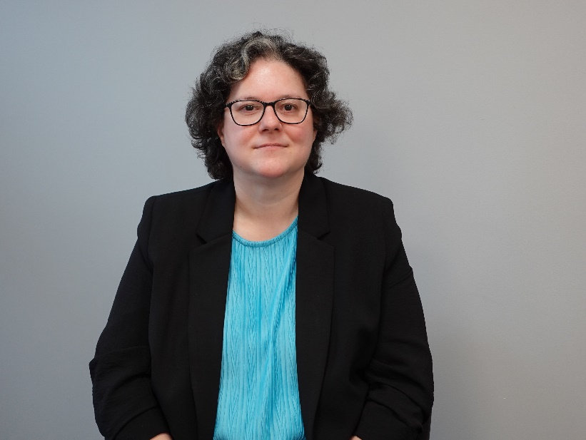

To watch Claire’s story, please click [**here**](https://vimeo.com/1094111947/05586a50b5)

**Job title:** Project Manager

**How beneficial is Access to Work for you?**

I have been using Access to Work for 3 years. Access to Work absolutely brings invaluable benefit – it means I can attain the same level of employment as my peers, it allows me to do what I need to do at work. I don’t have to struggle with the need for support. Bringing in that interpreter allows my performance at work to be at my best and not lag behind that of my peers.

**How accessible would you say Access to Work is? From the application to receiving your budget, and making complaints if you have done this?**

My application to Access to Work, originally, actually went very smoothly, communicating with them. But the renewal process is a hugely different experience, much more complex, and it’s actually still ongoing now.

My renewal process started, really, last year. At around that time, I was also having a change of role at work – a promotion. So, I used the opportunity to let Access to Work know about that change. But somehow, things just got extremely complicated. And so, since October I’ve had no ATW budget at all. It was only in January that I finally received my new ATW award. Disappointingly, I saw that it had been massively reduced compared to what I need. So, I had to send another “Change of Circumstances” form to them. But then, it seemed like I was being put through the entire process again from the very start, with a different case handler, which wasn’t nice to experience; it was extremely stressful. It seemed to me that the process was not straightforward at all. Working with them is not a two-way street; I have to repeatedly do a lot of chasing from my end. I raised a complaint about it, but it really didn’t seem to have any effect. In the end I have had to involve my local MP. But the whole thing is still ongoing.

**If there are any issues with Access to Work, what do you think needs to be done to improve and change this?**

I understand that Access to Work (as a scheme) is enforcing its procedures on us. And I am also aware that Access to Work is funded by the taxpayer; I get that. And of course, I’m not here to spend that money frivolously. But Access to Work really needs to understand our job roles – what’s involved in the work. They are just not deaf aware. I have tried to challenge them – to try to open up that two-way communication. Sometimes I try to educate them, but they have been very resistant to that in the past, frustratingly. It makes working with them very slow-going. If Access to Work is interested in making improvements, they need to be open to that two-way discourse, learn their lessons, and move on. Not incessant delays like they currently have.

**Desmond**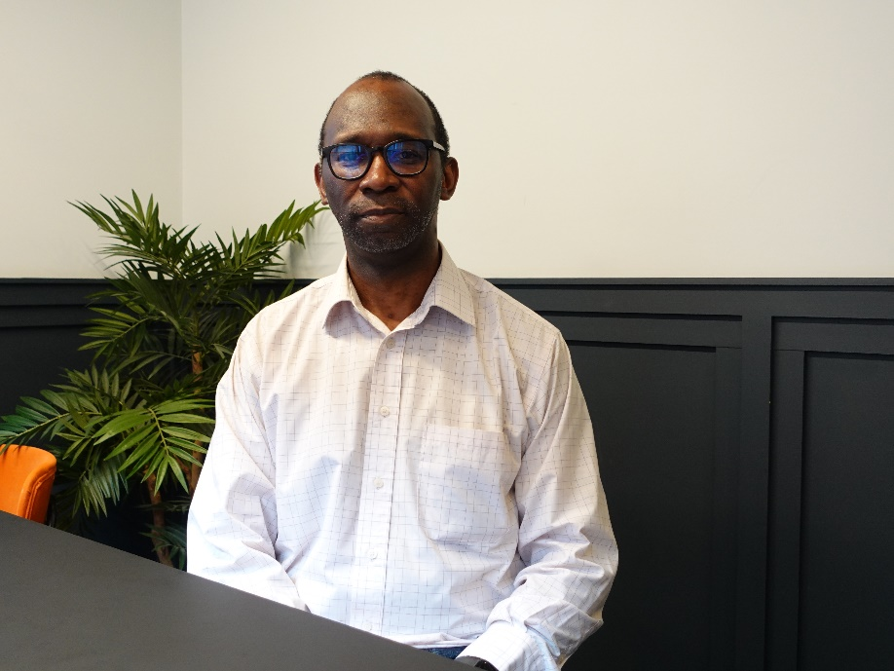

To watch Desmond’s story, please click [**here**](https://vimeo.com/1094099674/fdbb8080aa)

**Job title:** Support Worker

**How long have you used Access to Work?**

I have been using Access to Work for over 10 years. When I first found out about Access to Work, it was more than 10 years ago, I was at the Jobcentre, they gave me a leaflet with information about Access to Work. But now, after COVID, the application process is now online, and for me, I find it more complicated and difficult.

**What is it like using the new online portal for Access to Work invoices?**

Submitting invoices online is tricky. Once I go in the system to claim an invoice, I can follow the steps fine. It is a smoother and quicker process. But, recently, the system has become stricter. Now, I have to put the date, hours, when claiming invoices. With my VRS budget, I have 320 minutes, but the system is not compatible, that makes it challenging to claim my VRS hours. With interpreters' hours, I can claim this on the portal but with VRS, it is logistically difficult to input on the portal.

**Are/Were your employers aware of Access to Work?**

I had to explain to my previous employer, about what Access to Work is, more than once. And they still didn't understand. They were confused about who is responsible for paying; they thought it was their responsibility to pay. I had to repeatedly explain everything; they were not aware. That should be Access to Work's responsibility to educate employers about Access to Work. Rather than me having to constantly explain. It's frustrating to do that.

**Hamza**

To watch Hamza's story, please click [**here**](https://vimeo.com/1096205924/3a4f256183?share=copy)

**Job title:** Language Support Professional

**Was the process of applying for Access to Work easy?**

Five years ago when I applied for Access to Work, the process was easy. I didn’t have to complete a paper form, everything was online. I let them know what my job role was, as well as other details. I applied online, with my support worker who told me what was needed. I filled everything in and sent it off.

Compared to then, the process now is very different. There’s much more jargon used, the process is much stricter, much more complex. That’s the way it is now.

**How accessible would you say Access to Work is? From the application to receiving your budget, and making complaints if you have done this?**

The processes of Access to Work, from application to complaints, to getting the grant itself, is absolutely not accessible at all. Not for the deaf community, not at all. You have to rely on email being the only method of communication with them, which can be a barrier for some deaf people, because there are some members of the deaf community who are not able to use the English language. The extensive use of written English by Access to Work leads many deaf people to disengage with it, which affects deaf employment. And not just the community, but it actively affects me on an individual level. Yes, I can parse English with no problem, but it is still exhausting to read reams and reams of emails, respond to them, and then wait three, four, five days, even one or two weeks for a response. And I don’t even know who I would complain to; there isn’t a clear complaints procedure. Should I complain to the advisor dealing with me, or go above them to the management at the top of Access to Work? I just don’t know.

(Hamza’s story continued) **In what ways, if any, do you think your identities as well as being deaf, have influenced any issues you experienced with Access to Work or your employers?**

So, yes, I am profoundly deaf, but I do also embrace a number of other identities. And I have noticed in dealing with them that Access to Work, not just my case manager, but the whole organisation, the system, the management, people who work there, do seem to have a certain attitude towards people with additional identities. For example, people like me – I’m Asian, with other mixed backgrounds. And I feel like… they treat us differently to other people. Other deaf people who have privileges that we don’t have. This community who are deaf and have different backgrounds – we may be Asian, Muslim, etc. We are falling way behind, and we really need to square that up, along with meeting Access to Work’s expectations. And so, my additional identities do double up the labour I need to do to jump through the various hoops Access to Work sets for me in order for me to obtain that grant.

**William** 

To watch William’s story, please click[**here**](https://vimeo.com/1094152271/751e4f60d6?share=copy)

**Job title:** University Senior Co-Ordinator and Student Caseworker

**How long have you used Access to Work, and how did you find out about it?**

I've used Access to Work for about ten years now, and all the time I've been working at a university. Access to Work came recommended from the deaf community. I didn't discover it myself. It's more of... being passed down from generations of other people recommending me to get support from Access to Work. Really, you have to be "in the know" to know about Access to Work.

**In what ways, if any, do you think your identities as well as being deaf have influenced any issues you experienced with Access to Work or your employers?**

I'm deaf, but I'm also partially blind. So, I feel that if you have two different kinds of disabilities, Access to Work will make it more difficult for you.

I feel the more additional needs that you have, the more complicated they will make it for you. Because of my additional needs, being partially blind, I'd need a bigger screen as opposed to just a screen. And because of my needs, they (the Access to Work staff) make it so... complicated, to the point where I feel side-lined because I'm "too" complicated. Because of that it just becomes such a big ball of stress really to deal with them because you're having two separate conversations. One's about being partially blind and the second is being deaf. But they never see them both being two of the same things. And, because of that it's almost like I have to deal with two different departments.

**How beneficial is Access to Work for you?**

When Access to Work does work, it works for everyone, in everyone's favour. I think attitudes need to change. There’s lots of things that people put in place, but we need to take a step back and look at how deaf people would benefit from it, and then, for people to have more of a positive attitude - "Oh, if we simplify Access to Work, it actually caters for everyone!" It's a win-win situation.

Deaf people can work, we are perfectly capable of doing whatever it is that we are employed to do. But give us that support and we will do the job just as well as everyone else.

# Conclusion

**](https://vimeo.com/1101234587/1d180c2593)**

Everyone should be able to get the support they need at work, from day one. Deaf people have the right to the same opportunities as everyone else at work. Access should not be something additional, complicated or an afterthought. It is a basic right that we, as deaf people, have to access employment, progress and thrive in our careers.

We know work is important. Having a job helps us to live a healthy and happy life. That is why it is so important that Access to Work is fit for purpose and works for deaf people. Without the right support at work, our health and wellbeing are poor. That’s why we are calling for reform, not cuts to Access to Work. We are asking for changes that will make Access to Work better. The scheme is a lifeline; it helps us get jobs and stay in work. But at the moment, the scheme is confusing, slow and stressful for many deaf people.

* Deaf people are waiting up to 10 months for Access to Work to be implemented.
* Only 15% of people told us they had a good experience with Access to Work.
* 26% told us that Access to Work staff do not understand their needs as a deaf person

Access to Work is not all bad. When it works well, it works. It gives deaf people the opportunity to do their job, just like anyone else. That is why we want the Government to improve Access to Work, not make cuts that would have an impact on deaf people, risking our careers.

Our community wants to work with the Government to do this. Together, we can make workplaces fairer and equitable for everyone: where deaf people can thrive at work, on par with our peers.

# Research and terms

**](https://vimeo.com/1101240982/1d3f76f602)**

Our research was carried out through an online survey called ‘Deaf at Work’. This was designed to gather insight into the experiences of deaf, hard of hearing, people with hearing loss and people with tinnitus when they navigate employment. Access to Work was one of the core areas we asked respondents to share their experiences on. The survey was open from 31 October 2024 and closed 21 December 2024. Our survey asked open ended questions in order to gather the lived experiences of those using Access to Work. Therefore, percentages do not reflect answers to multiple choice questions, rather similar responses to open ended questions. We have developed a hybrid report – using both quantitative and qualitative data. We had 689 responses, 25 responded in British Sign Language.

**Terminology**

1. **Lowercase ‘d’ for deaf**

Throughout this report, we refer to deaf people using lowercase ‘d’ rather than ‘D’. This is because in 2023, SignHealth reviewed our terminology. Our deaf together campaign, launched in 2023, involves deaf people from a range of identities and communication styles, bringing new and different perspectives. It is important for us to acknowledge these range of identities in the terminology we use.

As part of our review of terminology, we gathered feedback from our deaf colleagues (75% of our workforce are deaf) and our deaf trustee members (75% trustees are deaf). The consensus was that ‘D/deaf’ is dated and divisive. We recognise that all deaf individuals whether they use BSL or not, often face similar barriers.

In 2024, we rolled out changing our terminology from ‘Deaf’ to ‘deaf’ to be inclusive for all deaf people with different hearing levels, communication preferences and identities.

At SignHealth, we work with deaf people who are BSL signers and those with other communication preferences. ​

We want to reflect the diversity of people that we work with and we encourage staff to decide how they would like to identify themselves.

1. **Access to Work / ATW**

We interchangeably use Access to Work and an abbreviated version ‘ATW’. Our community regularly referred to Access to Work as ‘ATW’ in their responses to our Deaf at Work survey.

1. **Referring to the scheme vs individuals/managers**

In most cases, Access to Work refers to the scheme itself. There are occasions throughout, such as the case studies e.g. William's or direct quotes from deaf survey respondents, where, Access to Work refers to the individual assessors and/or managers as a shorthand for the broader scheme

1. **Considerations**

As a deaf health charity, SignHealth are very aware of the importance of intersectionality and considering the layered experiences of multiple identities. Our research was conducted within a community of people who are predominantly deaf, hard of hearing, with a hearing loss and tinnitus, but we are hugely supportive of other disability groups who use Access to Work and eager to share our learnings together for change.

This report was authored by Kirsty Jade Dix, Campaigns Officer at SignHealth. Kirsty is passionate about ensuring that deaf people's lived experiences and views shape policy outcomes. She has been integral in SignHealth's involvement in the Government's Pathways to Work consultation. Her work has supported collaboration among deaf organisations and individuals, and she has presented research to NHS and academic stakeholders. Kirsty has led an advisory group of deaf people from across the UK to support SignHealth's Campaigns and Policy Work. To contact Kirsty, email [kdix@signhealth.org.uk](mailto:kdix@signhealth.org.uk)

**](https://vimeo.com/1101581397/8b9e062d15?share=copy)**

This report was written as part of the deaf together campaign by SignHealth. All data is managed by SignHealth, a registered charity in England & Wales (1011056), and Scotland (SC044122).



deaf together is a campaign to end the inequalities deaf people face. We mean all deaf people including those who are deaf, hard of hearing, have hearing loss or tinnitus.

For any queries on the deaf together campaign, please email [hello@deaftogether.org.uk](mailto:hello@deaftogether.org.uk)

**The supporting organisations and individuals of this report are:**

Interpreters of Colour Network (IOCN)

National Registers of Communication Professionals working with Deaf and Deafblind people (NRCPD)

National Union of British Sign Language Interpreters (NUBSLI)

Association of Sign Language Interpreters (ASLI)

Nadeem Islam, Associate Artist for Fuse Theatre

Ciaran Stewart, Deaf and Disabled committee member for Equity

Asha Hylton

Hamza Shaikh

Claire Adshead

Desmond Spencer

William Ogden

1. Department of Work and Pensions, 11 March 2025 (provided via Freedom of Information Request)