

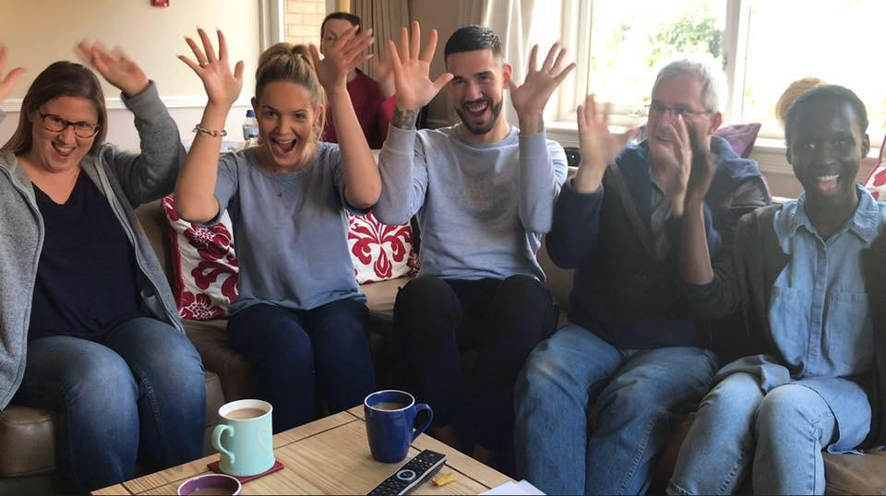

Service Administrator

Candidate Brief

Overview
Thank you for your interest in this exciting role. We hope that this pack gives you all the information you need to make your application.
We have ambitious plans to grow our social care services in line with our three year plan. You will play a key part in shaping quality systems and compliance for the new services.

You will be encouraged to learn and develop British Sign Language skills so that you can communicate with our teams and grow effective relationships with our deaf colleagues. We provide services directly in British Sign Language (BSL), we work in partnership with the NHS and local authorities and we also campaign for change.
75% of our staff at SignHealth are Deaf, and almost all our staff in services are fluent sign language users.
Our work is varied and aims to give Deaf people easier access to healthcare and information, as well as providing services which are not provided elsewhere.
Some of our work is funded on a case-by-case basis by the NHS or local authorities, and some is funded entirely by grants from trusts or by donations from individuals.

“We are a passionate and caring Deaf-led team working towards a future where there are no barriers to good health and wellbeing for Deaf people.”

About us
The charity was set up in 1986 as the Anastasia Trust in response to a lack of services for Deaf people with mental health issues. Over three decades, we’ve grown to provide a range of services that improve Deaf people’s lives.
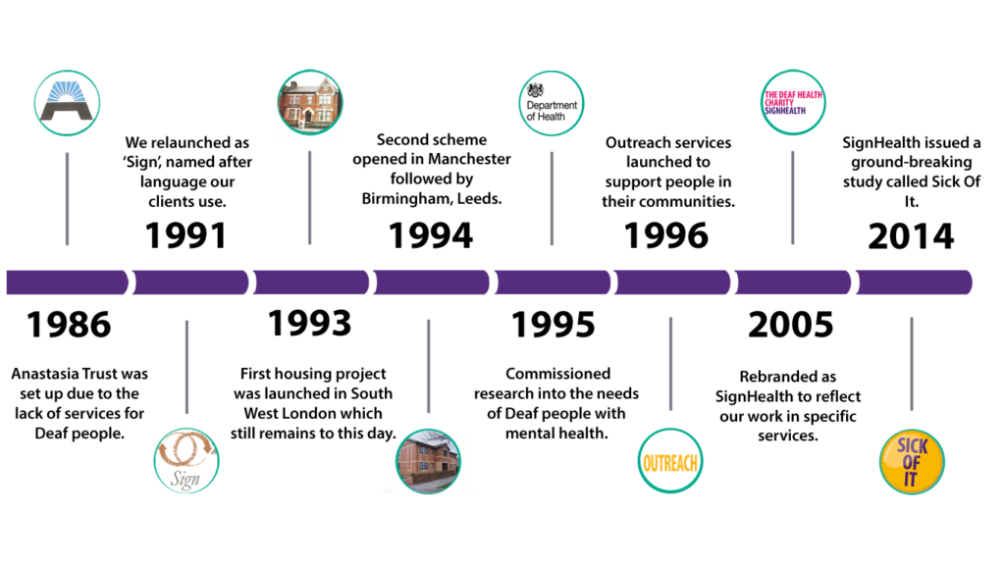
We have grown to deliver a range of services that improve the health and wellbeing of Deaf people. In the last thirty years we have set up a number of care homes, provided advocacy and outreach services, supported Deaf people at risk of domestic abuse, delivered therapy in British Sign Language, carried out important research and made vital information more accessible to Deaf people.

Our work is varied and aims to promote easier access to healthcare and information. We partner with the NHS and other services and take on projects, carry out research, and raise awareness.
The world has changed significantly since SignHealth began, not least huge advances in technology and the changing health and social care landscape. Things have changed within SignHealth too. In July 2017 we relocated our Head Office from Buckinghamshire to London. We have a new, award-winning, Board of Trustees, a refreshed strategy and we are focused on ensuring that the organisation is financially and commercially sustainable. There is a great deal to do to improve Deaf people’s health and wellbeing and we are determined to make a significant difference through our work.

What we do
Social Care
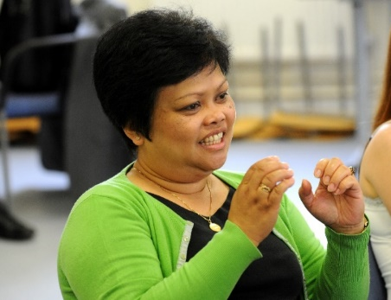
Our registered care and supported living homes, are for Deaf people with complex and long-term mental health issues. This is how we first began, and they remain a hugely important part of our services portfolio. Our five care homes and one supported living home gives service users their own bed-sit flat, and staff help the service users to build independence and increase confidence, as well as prompting and supervising medication. All service users and staff are sign language users, which helps to end the isolation many Deaf people experience when they are inappropriately supported in hearing services.
Therapies
SignHealth runs the only IAPT-compliant, BSL psychological therapy service for Deaf people with depression, anxiety, or similar mental health conditions. Sessions are carried out entirely in sign language, with a therapist who is fluent and often Deaf themselves. It means there is no interpreter in the room, which would slow down communication and reduce the intimacy which is important to this kind of treatment. An online service is now up and running which will enable more people across the country to access therapy in BSL.
Domestic Abuse services
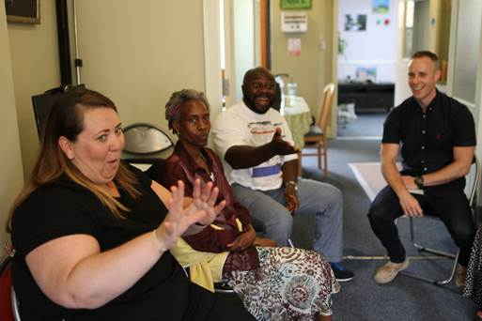
Our Domestic Abuse service is a unique service that supports Deaf men, women and children who are suffering domestic abuse. This is the only service in the UK and gives help and advice on how to be safe, and where to find refuge.
The service is across England. We have plans to expand this much needed service across the UK. The service also works with Deaf children and young people, teaching them about healthy relationships and staying safe online.

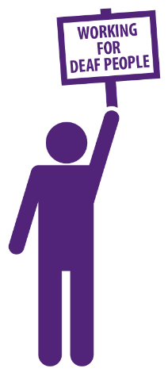
Campaigning and Research
Campaigning is an important part of our work, trying to change the way things are done so that Deaf people get an equivalent service to hearing people. We are raising awareness among the hearing public, offering solutions to health service workers, and pushing for change from the NHS and government.

Fundraising
We’ve got a strong history of fundraising at SignHealth and we want to increase our fundraised income in the future too. Whether from trusts, grant makers, central government, or private individuals we have an ambitious growth strategy for SignHealth which will need strong and reliable income streams.
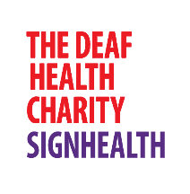
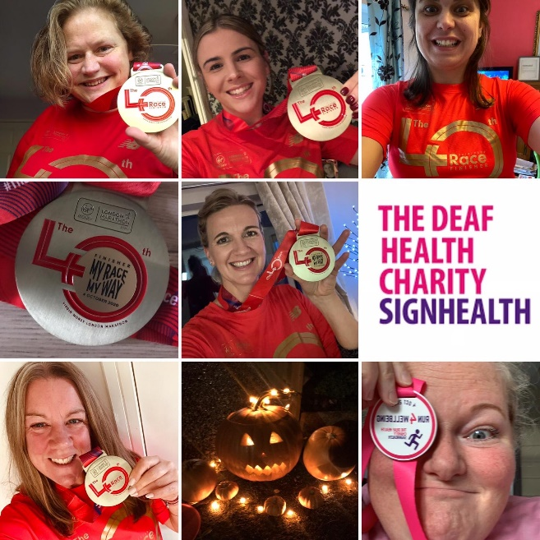


Follow us

@SignHealth

@SignHealth
@SignHealthCharity

Job Description – Service Administrator
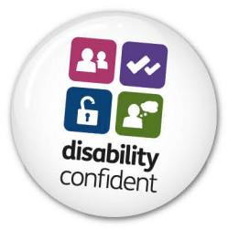
Role: Service Administrator for Brudenell Road and Constance Way

Location:

Leeds

Hours:

40 Hours per Week (Mon – Fr and Flexibility to work evenings occasionally)

Pay: £14.36 per hour

1 Background
  - The Deaf Health Charity SignHealth is a registered charity.

SignHealth is committed to bringing better healthcare and equality of service provision and healthcare access to Deaf people within the UK.

Improvements will be made through research, campaigning and partnership working with Deaf people, Deaf organisations, health services and other charities.

SignHealth provides services to Deaf people experiencing mental health problems
and/or complex needs. At present the organisation is working in the fields of supported living services, advocacy, outreach, psychological therapy and health promotion.

The duties of the Service Administrator are as follows:

1. General
- Answering telephone calls and take messages.
- To handle telephone enquiries, taking appropriate action and acting on own initiative which also prioritising the incoming work.
- Carrying out some typing for other SignHealth staff as necessary; i.e, Team Leader, support workers.
- Supporting team with communication e.g. translation of written material into BSL.
- Processing advertisements for vacancies, arranging interviews, booking rooms for interviews, sending out necessary information to applicants.
- Liaising with outside agencies and other professionals.
- Liaising with the Charity head office as required.
- Formulating staff and training and meeting’s agenda.
- Typing staff meeting minutes and filing as appropriate.
- Keeping a record of template documents.
- Updating Managers pack with policy documents as necessary.
- Monitoring observance of General Data Protection Regulations in the housing scheme.
- To handle photocopying and scanners and booking rooms.
- Attend training as required.
- Arranging and purchasing for supplies when necessary.
- Ordering and maintaining stationery supplies.
- Complying with the Charity Policies and Procedures.

2. Supporting Team Records
- Photocopying/Scanners
- Ensuring records of support team details e.g. staff names, addresses and personal details are up to date in the Inspection Unit file, Compliance and the Service Manager/Management has an up to date copy. Reviewing these on a monthly basis and completing for any new member of staff.
- Read/Sign documents for staff.
- Ensuring a list of supervision dates for all staff is produced on a monthly basis.
- Processing and keeping a computerised record of individual supervision minutes and ensuring copies are distributed to Service Manager and member of staff.
- Co-ordinating case review meetings by making sure that support workers have checked the availability of rooms, interpreters and sent out invitations to those attending.
- Ensuring all letters and reports are sent out at the appropriate times.

2. Assisting the Service Manager as follows
- Supporting the Service Manager as necessary.
- Helping Service Manager with filing.
- Ensuring that the Service Manager's movement chart is kept up to date and forwarded to Headquarters on a weekly basis if applicable.
- Typing the Service Manager's correspondence as dictated and other documents.
-Typing confidential reports as required.

Any other reasonable duties as required by the Service Manager and the team.

Person Specification

Qualifications & Training | Essential/Desirable
British Sign Language | D
Experience

Experience of managing a high volume of tasks | E
Experience of working in an office environment and working from home. | D
Experience of working within Adult Social Care | D
Experience of working with clients who have disabilities and Mental Health problems | D
Skills

Effective time management skills | E
IT Skills: including Microsoft Word, Excel, Outlook, PowerPoint | E
Confidence to build relationships with external agencies and other professionals | E
Able to prioritise work schedule to ensure workload is complete | E
Able to plan and organise own workload to ensure complete organistion | E
Able to work under pressure and complete tasks quickly and effectively | E
Able to work under strict management instruction | E
Able to work on their own and within a team | E
Able to quickly react to change and adapt to an environment that can quickly change | E
Knowledge

Understands the importance of confidentiality | E
Knowledge of Health and Safety | D
Ability

Ability to handle and answer telephone enquiries: With BSL interpreter if required | E
Able to support the team with communication | E
Ability to pay high attention to detail | E
Ability to coordinate case review meetings: Booking rooms, interpreters etc. | E
Ability to work on own initiative: being able to recognise the needs of the service | E
Have the confidence to report an issue when noticed. | E

HOW TO APPLY

We hope that the information provided has enabled you to make an informed decision about your application. Before you apply, please ensure you have read the job description and person specification in detail.

Applications should comprise a CV, including details of two referees. Please also provide a supporting statement (no more than two sides of A4) outlining the reasons behind your application. This should respond closely to the person specification, showing how you meet the requirements of the role.

Our diversity monitoring form (available on request) should also be completed and returned.

We positively welcome applications from deaf people and disabled people.

All documents should be emailed both to cevans@signhealth.org.uk and aroebuck@signhealth.org.uk

Please include your name in the subject field.

Contact
If you would like to arrange an informal discussion about the role or the process, please contact both cevans@signhealth.org.uk and aroebuck@signhealth.org.uk

